Titus Women’s Discipleship Summit
30 Days of Devotions
“Abide in Me and I in You ... the Key John 15:4.”
Day 10
“Then Elijah said to Ahab, ‘Go get something to eat and drink, for I hear a mighty rainstorm coming!’ ⁴²So Ahab went to eat and drink. But Elijah climbed to the top of Mount Carmel and bowed low to the ground and prayed with his face between his knees.” 1 Kings 18:41-42 (NLT)
Immediately after Elijah prayed, God sent fire down from heaven. The water-soaked offering and altar were completely consumed. When the people saw God’s mighty power in response to prayer, they fell face down on the ground and cried out, “‘The Lord-he is God! Yes, the Lord is God!’” (18:38-39) (NLT)
We find King Ahab is off eating and drinking, but not Elijah, he and his servant climbed to the top of Mount Carmel. He bowed with his face between his knees praying to the living God. Elijah sent his servant seven times to look out over the sea for evidence of rain. Elijah was undaunted that there was no sign of rain, I believe he continued praying until his servant saw a small rain cloud rising from the sea.
Have you ever wondered what Elijah prayed for? I tend to think Elijah was praising God for answered prayer.¹ He would have undoubtedly been humbled, being in the presence of the living God and witnessing His display of power.² I wonder also if Elijah wasn’t praying for the people across the land, that they would realize that Baal had no power, and that the God of Abraham, Isaac, and Jacob, is the one true God.
Since we met Elijah, we know that he was obedient to God and he trusted Him. We know that Elijah was a man of prayer and he experienced the power of it.
If you have been praying for something or someone for quite some time and you feel as though God has not answered. Please do not give up. Perhaps God’s silence is His answer, for today. Hold onto these two scriptures and trust Jesus with your prayer.
“‘My thoughts are nothing like your thoughts,’ says the Lord. ‘And my ways are far beyond anything you could imagine.⁹ For just as the heavens are higher than the earth, so my ways are higher than your ways and my thoughts higher than your thoughts.’” Isaiah 55:8-9 (NLT)
“Don’t worry about anything; instead, pray about everything. Tell God what you need, and thank him for all he has done.” Philippians 4:6 (NLT)
¹ 1 Kings 18:36-37
² 1 Kings 18:38
Prayer
Father, thank You that Your word brings such peace and truth. Thank You for how You have answered my prayers. Remind me to keep on, when keeping on is not easy. Father, this Daily Prayer by Elizabeth Elliot, I make it my own.
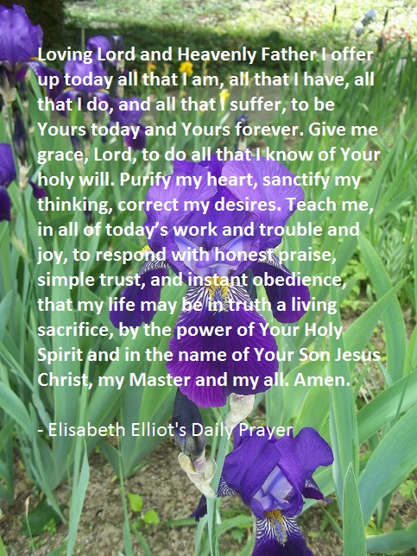
In Jesus Name, Amen
https://anglicanprayer.wordpress.com/2015/06/18/elisabeth-elliots-daily-prayer-as-a-prayer-card/

